DAY 23_Coding Challenge (Strings Only) – Ola Defect Analysis
Scenario
You are a Data Analyst at Ola. You receive complaint data as a single string. You must clean and analyze it using ONLY string operations.
Input (Single String)
data = "Ride101-Ramesh-Late Arrival-Bangalore, Ride102-Suresh-rude behavior-Hyderabad, Ride103-Mahesh-Late arrival-Bangalore"
Tasks (STRICTLY USING STRINGS)
Task 1: Clean the Data
- Convert entire string to lowercase
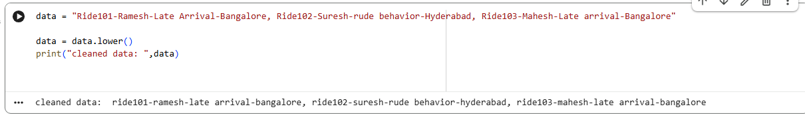
Task 2: Count Total Complaints
- Count how many rides (records) are present
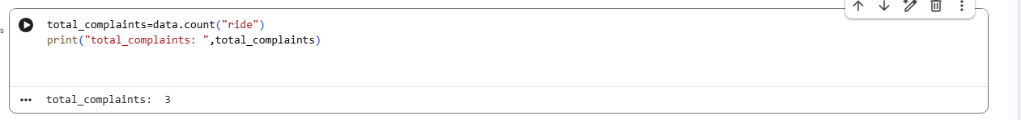
Task 3: Count "Late Arrival" Issues
- Count how many times "late arrival" appears

Task 4: Find Complaints from Bangalore
- Count how many times "bangalore" appears
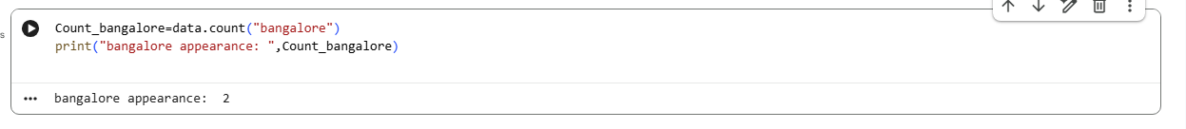

Task 5: Extract First Driver Name
- From first record → extract driver name
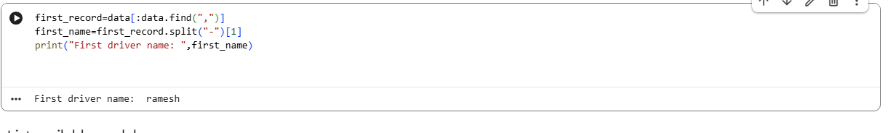
Task 6: Replace Issue Names (Standardization)
Replace all:
o "rude behavior" → "rude_behavior"
o "late arrival" → "late_arrival
